USER INTERFACE METAPHORS

A user interface metaphor is a concept referring to the employment of what users are familiar with (in the real-world) to help/enable them understand how to use/interact with a system/device (in the computing world).

We have experienced how metaphors have been widely and extensively used to describe various aspects and functionalities of the user interface e.g. windows, buttons, menus, dragging, pointing, etc.
`
Question: Describe problems with metaphors.

Examples:

Application Metaphor Familiar knowledge

Operating environment Desktop Office tasks, file management

Spreadsheets Ledger sheet Columnar tables

File storage Piles Categorizing objects in terms of urgency,
projects, etc

Other examples:

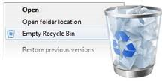

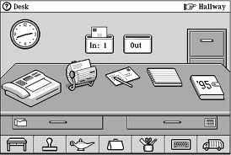

Note:
- We should capitalize on user’s existing knowledge (e.g. as we noted before in visual perception & their mental models), and the use of user interface metaphors.
However, the challenge is to find a suitable metaphor; the problem is to design the system so that, first, it follows a consistent, coherent conceptualization (a design model), and, second, so that the user can develop a mental model of that system (a user’s model) consistent with the design model.

